DAY 4

LAB EXERCISE 1:

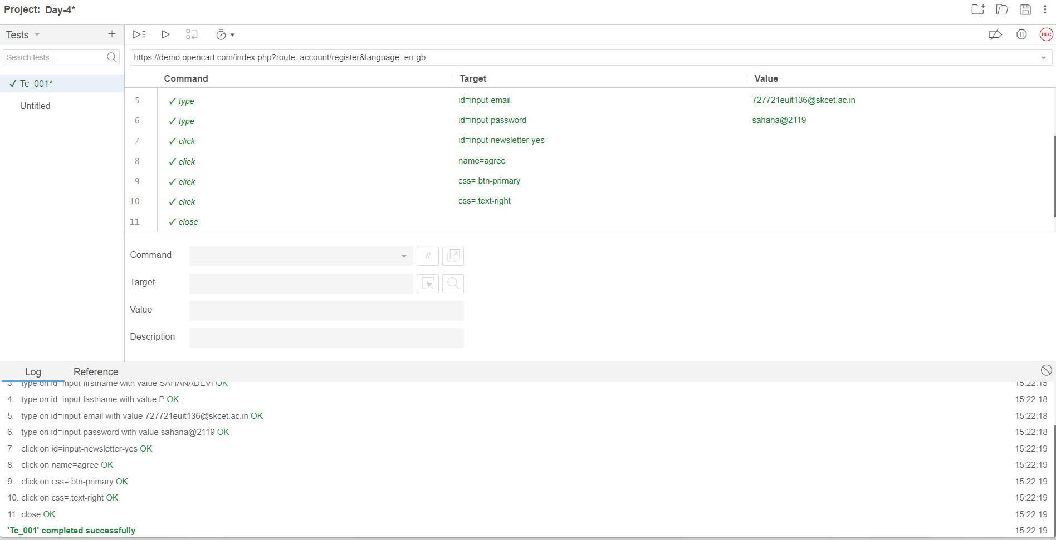

LAB EXERCISE 2:

Code:

package com.Test.Testing;

import org.openqa.selenium.By;

import org.openqa.selenium.WebDriver;

import org.openqa.selenium.WebElement;

import org.openqa.selenium.chrome.ChromeDriver;

import org.openqa.selenium.chrome.ChromeOptions;

import io.github.bonigarcia.wdm.WebDriverManager;

public class App

{

public static void main( String[] args )throws InterruptedException

{

// ChromeOptions co=new ChromeOptions();

// co.addArguments("--remote-allow-origins=*");

// WebDriverManager.chromedriver().setup();

// WebDriver driver=new ChromeDriver(co);

// driver.get("https://www.google.com/");

ChromeOptions co=new ChromeOptions();

co.addArguments("--remote-allow-origins=*");

WebDriverManager.*chromedriver*().setup();

WebDriver driver=new ChromeDriver(co);

// driver.get("https://www.google.com/");

// CE 02

driver.navigate().to("https://demo.opencart.com/index.php?route=account/register&language=en-gb");

WebElement fname=driver.findElement(By.*id*("input-firstname"));

fname.sendKeys("SAHANADEVI");

WebElement lname=driver.findElement(By.*id*("input-lastname"));

lname.sendKeys("P");

WebElement email=driver.findElement(By.*id*("input-email"));

email.sendKeys("727721euit136@skcet.ac.in");

WebElement pass=driver.findElement(By.*cssSelector*("input#input-password"));

pass.sendKeys("skcet");

Thread.*sleep*(5000);

WebElement sub=driver.findElement(By.*id*("input-newsletter-yes"));

sub.click();

}

}



Output:

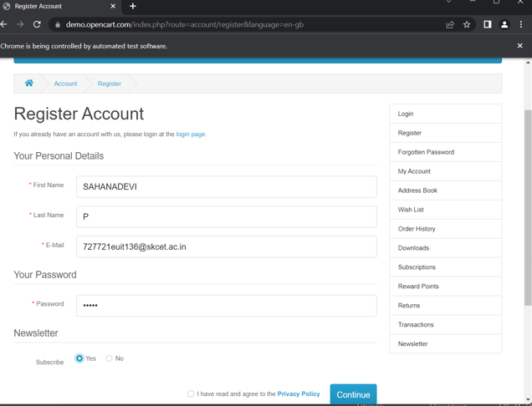

LAB EXERCISE 3:

package com.Test.Testing;

import org.openqa.selenium.By;

import org.openqa.selenium.WebDriver;

import org.openqa.selenium.chrome.ChromeDriver;

import org.openqa.selenium.chrome.ChromeOptions;

import io.github.bonigarcia.wdm.WebDriverManager;

public class CE03 {

public static void main( String[] args ) throws InterruptedException

{

ChromeOptions co=new ChromeOptions();

co.addArguments("--remote-allow-origins=*");

WebDriverManager.*chromedriver*().setup();

WebDriver driver=new ChromeDriver(co);

// driver.get("https://www.google.com/");

driver.navigate().to("https://demo.opencart.com/index.php?route=checkout/voucher&language=en-gb");

driver.findElement(By.*xpath*("//*[@id=\"input-to-name\"]")).sendKeys("SAHANADEVI");

driver.findElement(By.*xpath*("//*[@id=\"input-to-email\"]")).sendKeys("727721euit136@skcet.ac.in");

driver.findElement(By.*xpath*("//*[@id=\"input-from-name\"]")).sendKeys("RENU");

driver.findElement(By.*xpath*("//*[@id=\"input-from-email\"]")).sendKeys("727721euit138@skcet.ac.in");

Thread.*sleep*(5000);

driver.findElement(By.*xpath*("//*[@id=\"input-theme-7\"]")).click();

driver.findElement(By.*xpath*("//*[@id=\"input-message\"]")).sendKeys("Happy Birthday !");

driver.findElement(By.*xpath*("//*[@id=\"form-voucher\"]/div[8]/div/div/input")).click();

}

}

OUTPUT:

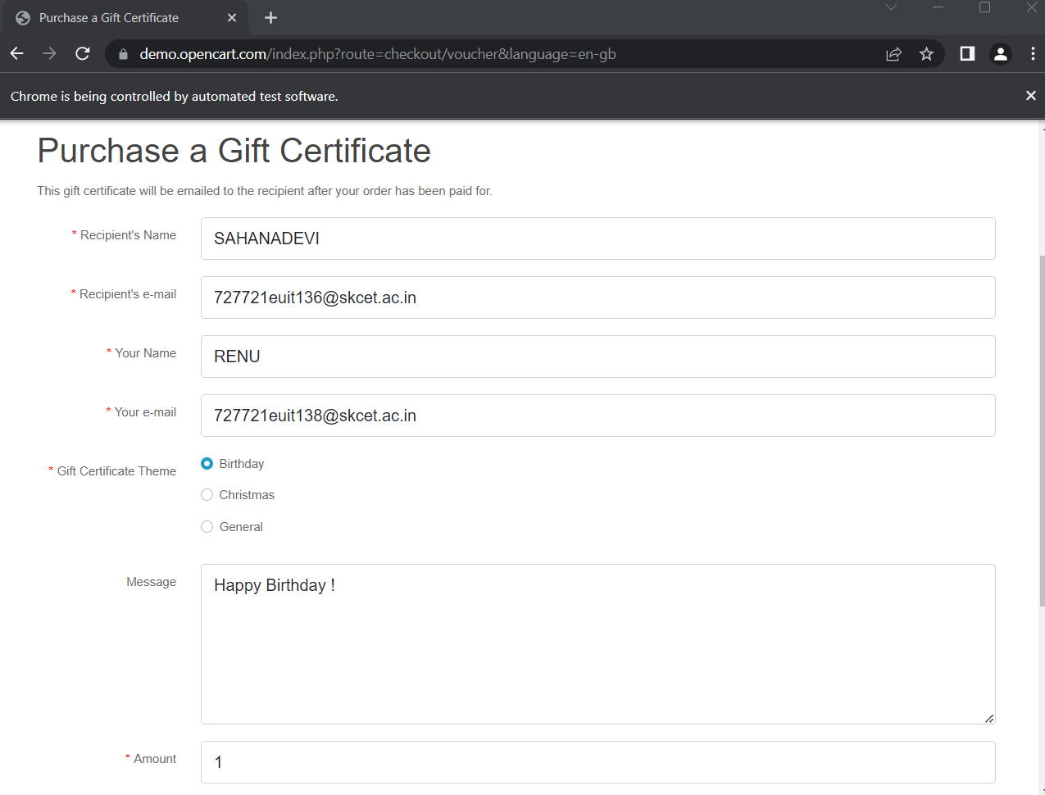

LAB EXERCISE 4:

package com.Test.Testing;

import org.openqa.selenium.By;

import org.openqa.selenium.WebDriver;

import org.openqa.selenium.chrome.ChromeDriver;

import org.openqa.selenium.chrome.ChromeOptions;

import io.github.bonigarcia.wdm.WebDriverManager;

public class CE4 {

public static void main(String[] args) {

ChromeOptions co=new ChromeOptions();

co.addArguments("--remote-allow-origins=*");

WebDriverManager.chromedriver().setup();

WebDriver driver=new ChromeDriver(co);

driver.navigate().to("https://j2store.net/free/");

driver.manage().window().maximize();

driver.findElement(By.xpath("//*[@id=\"Mod112\"]/div/div/ul/li[1]/h4/a")).click();

driver.navigate().back();

driver.navigate().forward();

driver.navigate().refresh();

driver.close();

}

}

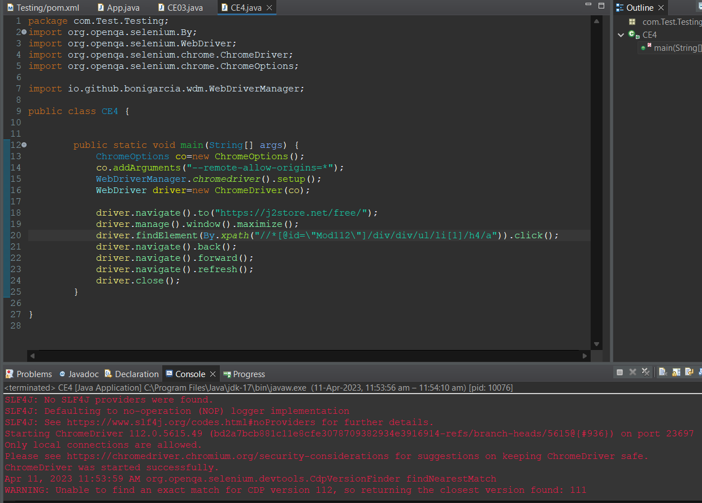

Output:

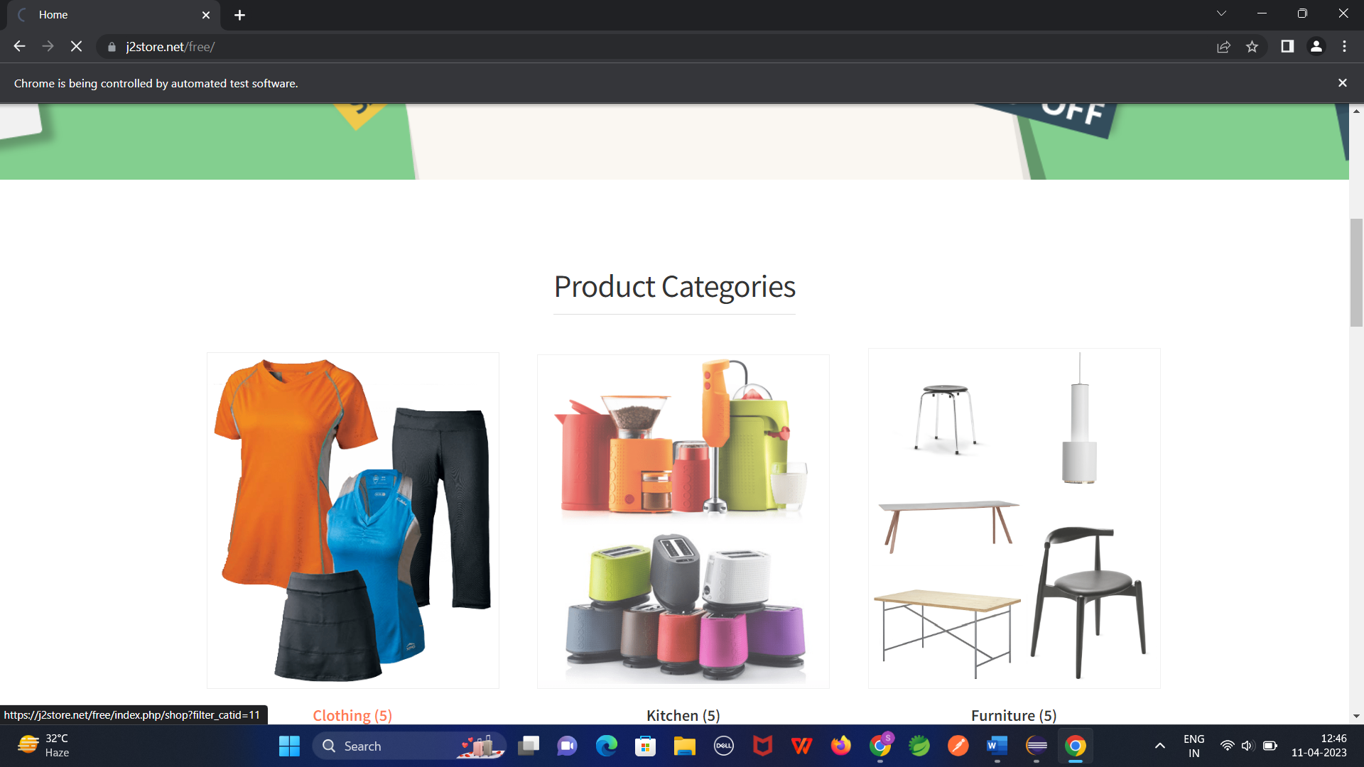

LAB EXERCISE 5:

TASK:5.1

package com.Test.Testing;

import org.openqa.selenium.By;

import org.openqa.selenium.WebDriver;

import org.openqa.selenium.chrome.ChromeDriver;

import org.openqa.selenium.chrome.ChromeOptions;

import io.github.bonigarcia.wdm.WebDriverManager;

public class CE5 {

public static void main(String[] args) throws InterruptedException {

ChromeOptions co=new ChromeOptions();

co.addArguments("--remote-allow-origins=*");

WebDriverManager.chromedriver().setup();

WebDriver driver=new ChromeDriver(co);

driver.navigate().to("https://j2store.net/free/");

String CurrentUrl=driver.getCurrentUrl();

String expectedUrl="https://j2store.net/free/";

if(CurrentUrl.equals(expectedUrl)) {

System.out.println("Url is Matched");

}

else {

System.out.print("Url is not Matched");

}

Thread.sleep(5000);

driver.findElement(By.xpath("//*[@id=\"Mod112\"]/div/div/ul/li[1]/h4/a")).click();

String CurrshopUrl=driver.getCurrentUrl();

String ExpShopUrl="https://j2store.net/free/index.php/shop?filter_catid=11";

if(CurrshopUrl.equals(ExpShopUrl)) {

System.out.println("Shop Url is Matched");

}

else {

System.out.println("Shop Url is not Matched");

}

}

}

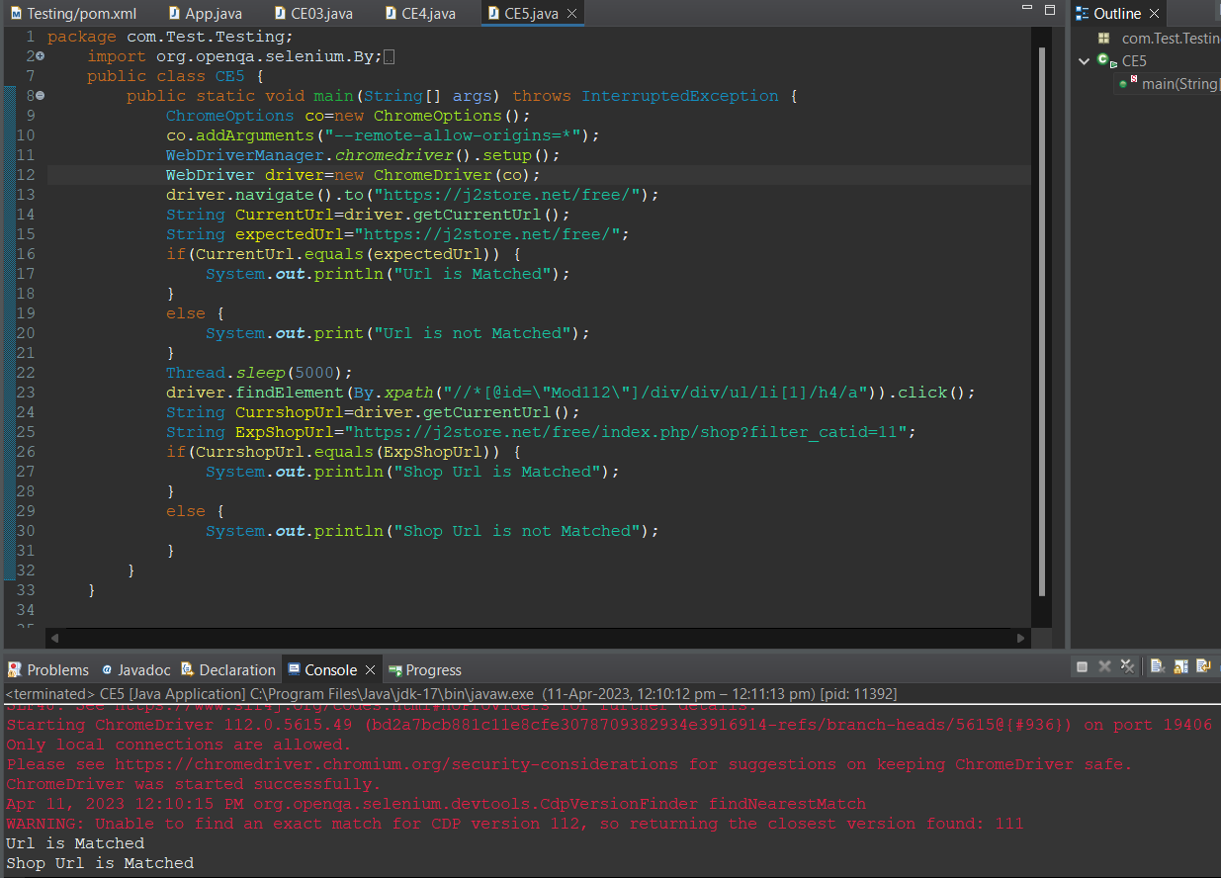

TASK:5.2

package com.Test.Testing;

import java.util.List;

import org.openqa.selenium.By;

import org.openqa.selenium.WebDriver;

import org.openqa.selenium.WebElement;

import org.openqa.selenium.chrome.ChromeDriver;

import org.openqa.selenium.chrome.ChromeOptions;

import io.github.bonigarcia.wdm.WebDriverManager;

public class CE52 {

public static void main(String[] args) {

ChromeOptions co=new ChromeOptions();

co.addArguments("--remote-allow-origins=*");

WebDriverManager.chromedriver().setup();

WebDriver driver=new ChromeDriver(co);

driver.navigate().to("https://j2store.net/free/");

driver.findElement(By.xpath("//*[@id=\"Mod112\"]/div/div/ul/li[1]/h4/a")).click();

List<WebElement> li=driver.findElements(By.xpath("//h2[@itemprop='name']"));

for(WebElement link: li) {

System.out.print(link.getText()+",");

}

}

}

